Request

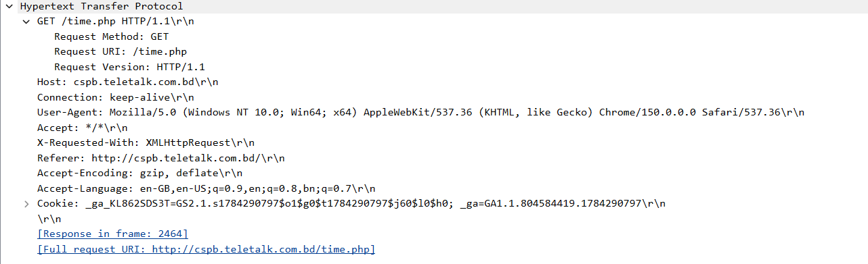

For request Hypertext Transfer Protocol, request method is Get, request version HTTP version 1.1, connection keep-alive( so further request can be done), accept language - US English

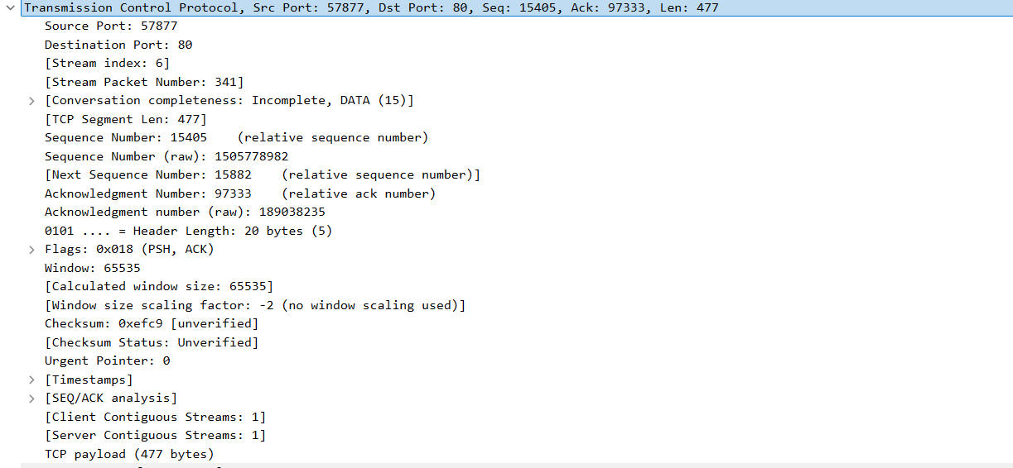

For request transmission Control Protocol, Source port is 57877 and destination port is 80, Sequence number is 15405 , next sequence number is 15882 , Acknowledge Number is 97333, Header Length is 20 bytes , windom- 65535

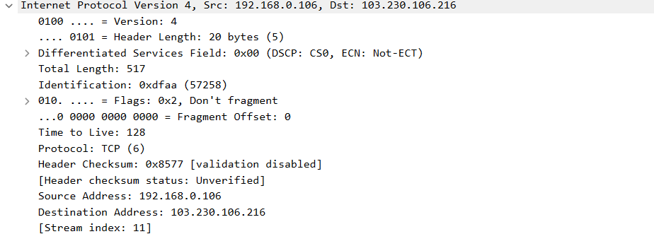

For Request Internet Protocol, Header Length 20 bytes, Source IP address is 192.168.0.106
And destination IP address is 103.230.106.216

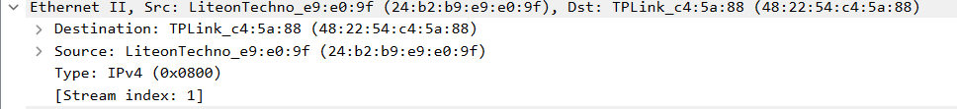
Here, Destination MAC address, 48:22:54:c4:5a:88 and Source MAC address 24:b2:b9:e9:e0:9f , IPv4

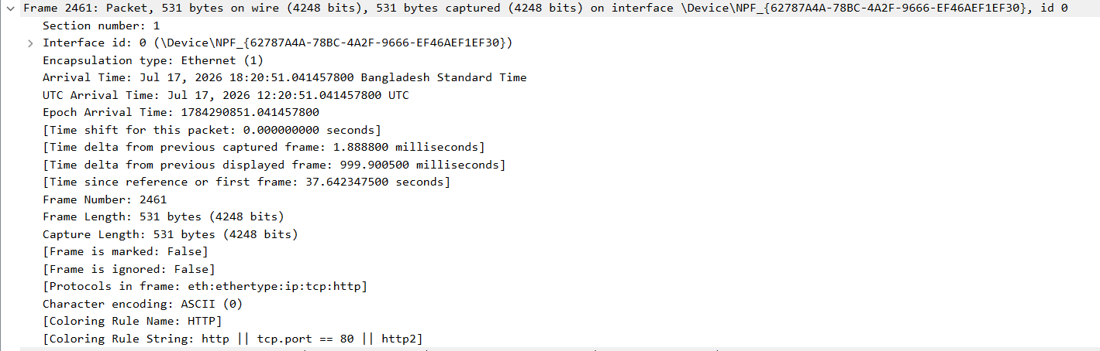
Frame Number 2461 ,Frame Length 531 bytes, Capture Length 531 bytes, Arrival time is 17 July, 2026

Response

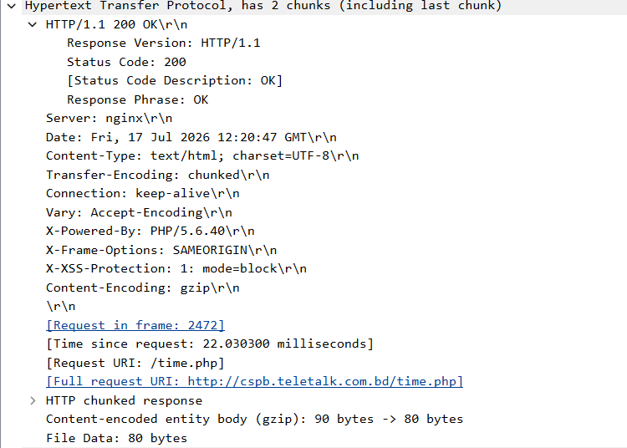

For Response Hypertext Transfer Protocol, request version HTTP version 1.1, connection keep-alive( so further request can be done), Response Phrase OK and Status Code-200(so message delivered successfully) , Date - Friday ,17 July 2026 , file data 80 bytes

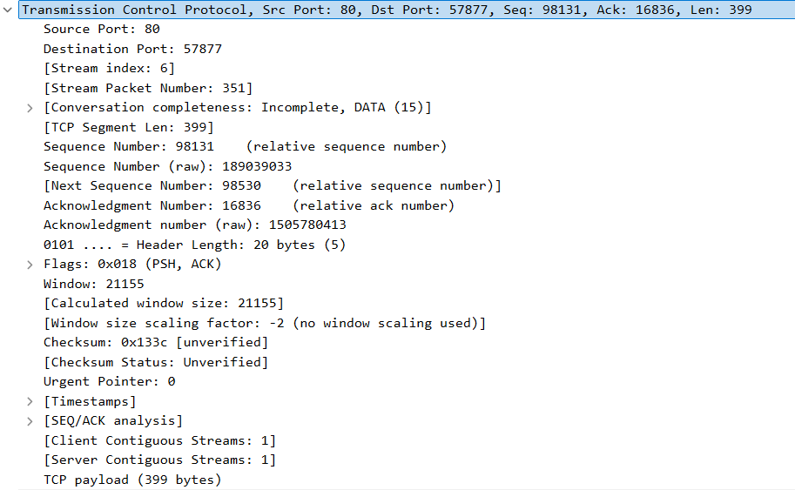

For Response transmission Control Protocol, Source port is 80 and destination port is 57877, Sequence number is 98131 , next sequence number is 98530 , Acknowledge Number is 16836, Header Length is 20 bytes , windom- 21155

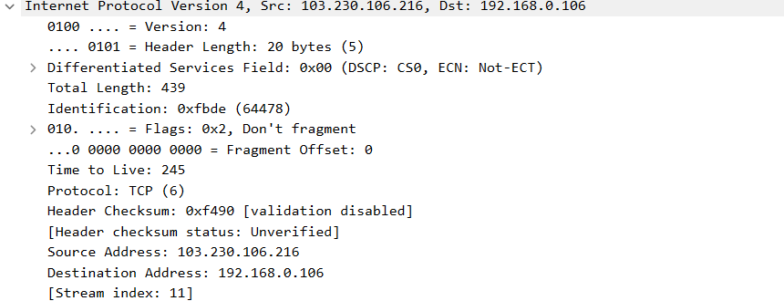
For Response Internet Protocol, Header Length 20 bytes, Destination IP address is 192.168.0.106
And Source IP address is 103.230.106.216

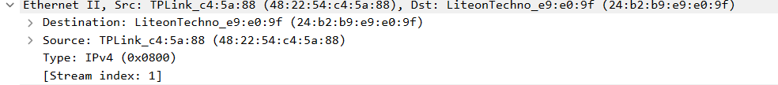

Here, Source MAC address, 48:22:54:c4:5a:88 and Destination MAC address 24:b2:b9:e9:e0:9f , IPv4

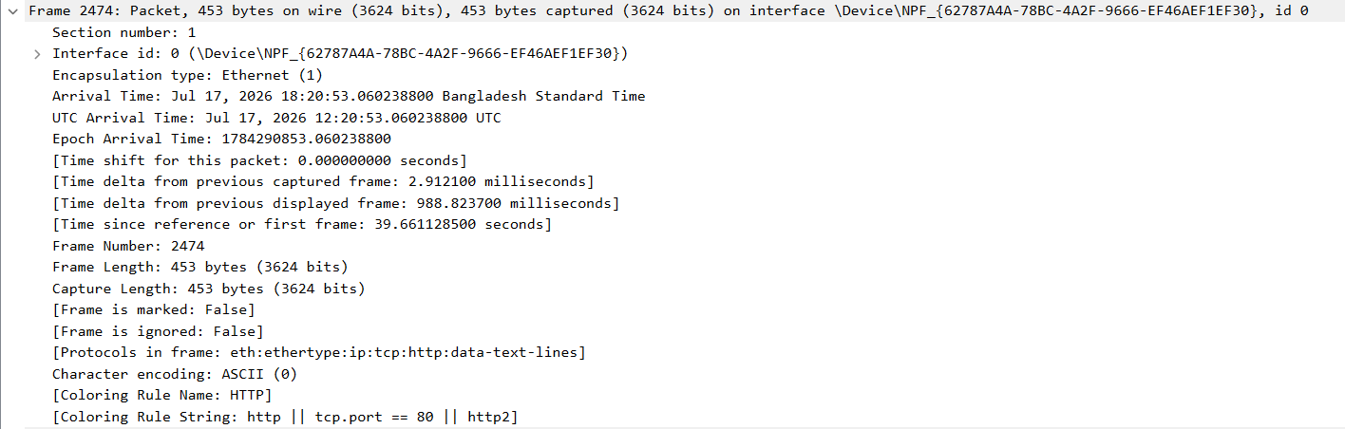

Frame Number 2474 ,Frame Length 453 bytes, Capture Length 453 bytes, Arrival time is 17 July, 2026

